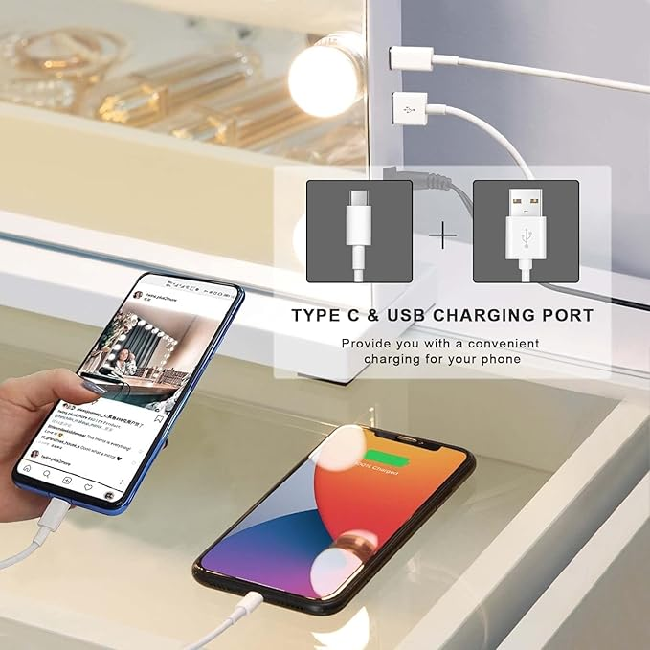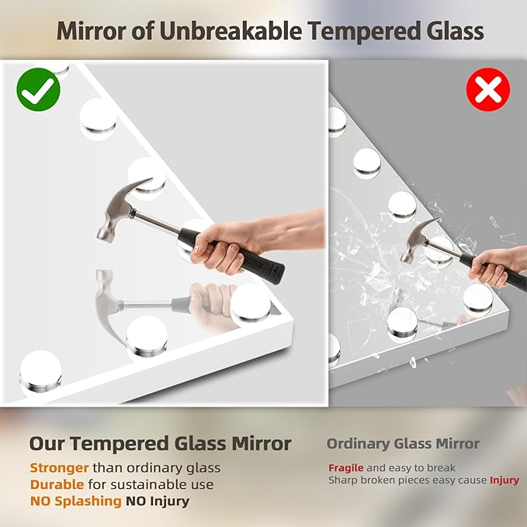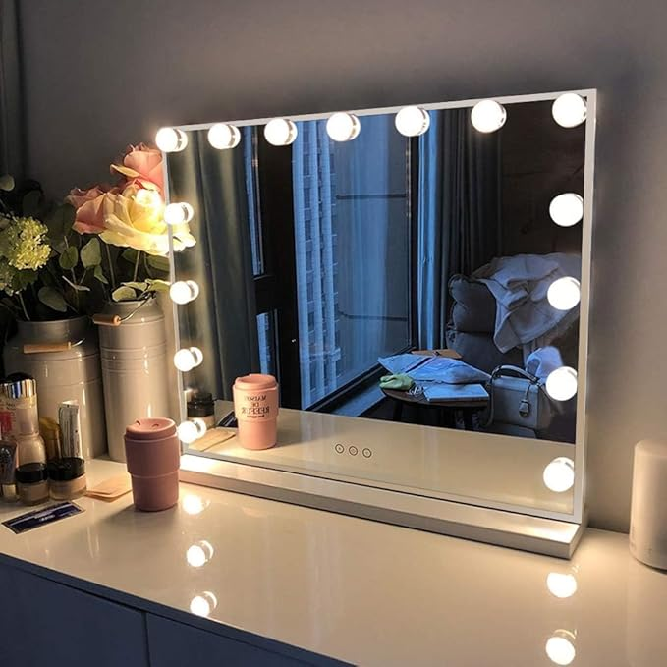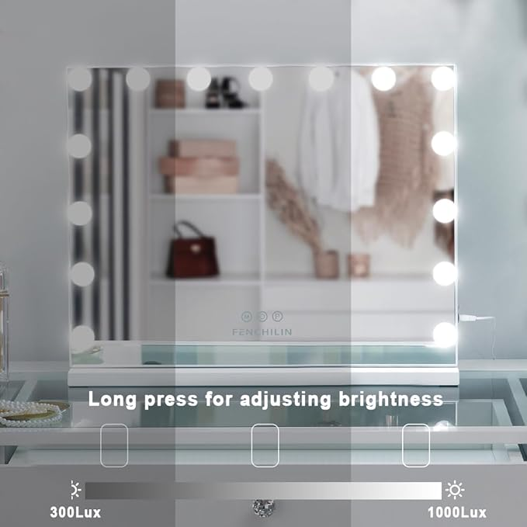

FENCHILIN Vanity Mirror with Lights, Hollywood Lighted Makeup Mirror with 15 Dimmable LED Bulbs for Dressing Room & Bedroom, Slim Metal Frame Design, White

**PRODUCT DESCRIPTION:**

|  |  |
| --- | --- |
| Brand | FENCHILIN |
| Room Type | Dressing Room, Bedroom, Bathroom, Glam Room |
| Shape | Rectangular |
| Product Dimensions | 18.11"L x 22.83"W |
| Frame Material | Stainless Steel |

**About this item**

* 【Type-C & USB Charge Port】FENCHILIN vanity mirror with lights has a popular size (22.8“ x 18.1”) to view your upper body. Two charging ports USB and Type-C on the side can charge your smartphone or other devices, brings you a convenient life
* 【Tempered Glass Makeup Mirror】: Hollywood Makeup Mirror is designed with high-definition shatter-resistant glass for clear, beauty reflection, desk mirror with Lights is safe of sturdy and unbreakable
* 【Adjustable Brightness & 3 Colors Lights】The lighted vanity mirror has a smart touch-sensitive button, easily switch the lighting color (warm light/natural light/cold light) to simulate the makeup effect in any occasion, and the adjustable brightness can meet your different lighting needs
* 【Memory Function & 10X Magnifying Mirror】This light up makeup mirror has memory function makes the light setting return to the last color temperature and brightness, meeting your usage habits and simplifying using. Mirror comes with detachable 10x magnifier is ideal for makeup detail, eyeliner and eyebrow shaping
* 【Detachable Mirror Base & Hanging setting】This large makeup mirror designed with detachable base and two back hole for nail. 1.Removing vanity mirror base with a screwdriver. 2.Knocking two nails on the wall. 3.hanging mirror on the wall